***Demonstration 5***

***Polymers***

***OBJECTIVES***

The objectives of this experiment are: (a) to demonstrate basic understanding of polymerization, (b) to provide examples of household polymers and their uses, (c) to observe the synthesis of nylon as an example of polymer.

***INTRODUCTION***

Polymers are very large molecules consisting of hundreds or thousands of smaller units, called **monomers**, linked together in a chain form. Synthetic polymers are a key reason for the high standards of living in many countries. Special characteristics that make polymers useful are their physical strength and low cost of production. Table 1 illustrates the uses of different kinds of polymers:

**Table 1:** Examples of Polymers and Their Uses.

|  |  |  |  |
| --- | --- | --- | --- |
| **Monomer** | **Formula** | **Polymer** | **Uses** |
| Ethylene | H2C=CH2 | Polyethylene | Packaging, bottles, films, sheets |
| Propene |  | Polypropylene | Outdoor carpeting, appliances |
| Vinyl chloride |  | Polyvinylchloride | Pipes, film, insulation, surgical gloves |
| Tetrafuoroethylene |  | Teflon | Nonstick cookware, mechanical parts |
| Acrylonitrile |  | Polyacrylonitrile | Acrylic textile fiber |
| Styrene |  | Polystyrene | Fast food containers, foam cups, toys |

The instructor has a collection of several types of commercial polymers that he or she will share with students.

*Question 1: List in Table 2 at least one practical use for each sample.* ***(8pnt)***

**Table 2:** Usage of Polymers.

|  |  |
| --- | --- |
| Name of Commercial Polymer | Its Usage |
|  |  |
|  |  |
|  |  |
|  |  |

All the plastics and fibers we encounter in our daily lives are polymers. One particular example of a polymer is **polystyrene**, which is the material from which Styrofoam is made. Polystyrene has a unique structure, a portion of which is shown below:



The repeating structural unit in this polymer is as follows:



The number of these structural units in a single molecule may exceed *6000,* resulting in a molecular weight of approximately *600,000*. Other polymers include the **natural fibers of cotton**, **wool, and silk**, as well as the synthetic fibers **polyester** and **nylon**. Familiar polymeric plastics include PVC (used to make plastic pipe and credit cards), polyethylene (used to make trash bags and soft plastic bottles), ABS plastic (used to make telephone cases and appliance cases), and rubber.

In this demonstration, nylon will be synthesized. There are several types of nylon, two of which are designated **nylon-66** and **nylon-6,10**. Nylon-66 is the type of nylon used to make women's hose.

Nylon-6,10, which is used to make gears, bushings, and combs, is similar in structure to nylon-66, with the difference being that one of the structural units has 10 carbon atoms in it rather than 6. The two structural units for nylon-6,10 are shown below:



These two structural units alternate in the nylon molecule. Note that the number designations for nylon-66 and nylon-6,10 refer to the number of carbon atoms in the respective structural units.

In this demonstration we will show how chemical reactions can be used to link monomers to yield polymeric species. The synthesis of nylon-6,10 will be used for this purpose.

EXPERIMENTAL PROCEDURE

1. ***Preparation of Nylon:***

The instructor has prepared solutions of sebacoyl chloride in hexane (1.5 mL sebacoyl chloride in 50 mL hexane) and hexamethylenediamine, in water (3 g of hexamethylenediamine and 1 g of sodium hydroxide in 50 mL of water):



Sebacoyle chloride



Hexamethylenediamine

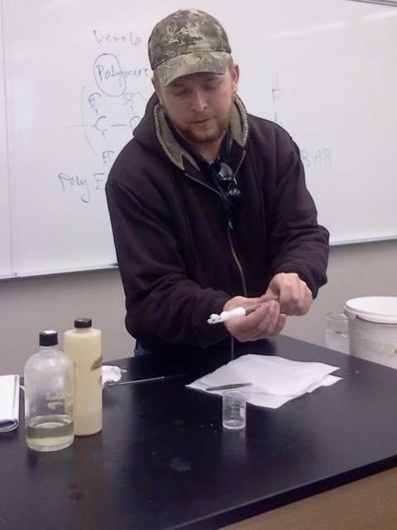

This image was taken as a student pulled out a nylon rope produced in a previous semester.

Note that a sebacoyl chloride molecule contains one of the structural units in nylon-6,10 and that a hexamethylenediamine molecule contains the other. Sebacoyl chloride is an example of a class of compounds called acid chlorides while hexamethylenediamine is an example of another class of compounds called amines.

Acid chlorides react with amines according to the following equation:



 + HCl

The nitrogen atom of the amine displaces the chlorine atom of the acid chloride, producing a type of compound known as an amide. The displaced chlorine atom ends up as hydrogen chloride.

Some of the hexamethylenediamine aqueous solution is poured into a small beaker and some of the sebacoyle chloride in hexane is poured upon the other solution. Since water and hexane are immiscible, they form two layers in the beaker as the less dense hexane floats upon the more dense water layer.

*Question 2: Observe what happens as the material is drawn out of the beaker (using forceps). What is the material? Describe it.*

***A wet nylon rope is pulled out. (6pnt)***

*Question 3: Draw the structure of Teflon.* ***(6pnt)***

